Lesson 7
Inverse Trigonometric Functions

sPECIFIC OBJECTIVES:
At the end of the lesson, the student is expected to:
- Define the inverse trigonometric functions and their principal values.
- Find the exact values of inverse trigonometric functions.

7.1 Inverse Trigonometric Functions
Definition 7.1 Inverse Trigonometric Functions

Inverse trigonometric functions are defined as follows:

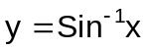 if and only if sin y = x and 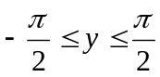 , where 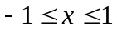.

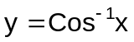 if and only if cos y = x and 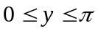 , where .

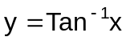 if and only if tan y = x and 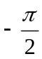< y < 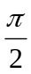 , for all real numbers x.

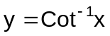 if and only if cot y = x and 0 < y < , for all real numbers x.

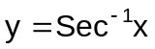 if and only if sec y = x and 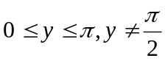 , where 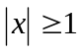.
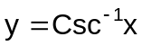 if and only if csc y = x and 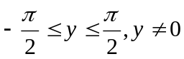, where .

Remarks:

To denote the function form of the trigonometric inverses, we use the initial capital letter, such as Arcsin or 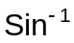, Arccos or 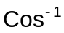, etc.

Principal values refer to restricted ranges of the inverse of the trigonometric functions. Range is so restricted to obtain function out of the inverse of the trigonometric function which is in its entirety is a relation. The following graphs demonstrate the restriction done.
п

п
2
п
2

-1
1
-п
2

y = arcsinx y = arccosx

п
п
2
п
2

-1
1
-п
2

y = arctanx y = arccotx

We denote principal values of sin⁻¹x as Arcsinx. Observe that the initial letter a is in upper case A. Whereas 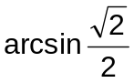 represents an infinite set of numbers, 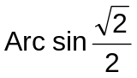 represents the single number 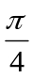.

The principal trigonometric function and its inverse is summarized in the table below.

Principal Trigonometric Function | Inverse Trigonometric Function
1. y = sinx D: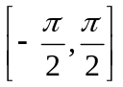  R: [-1,1] | 1. y = Arcsinx D:[-1,1]  R:
2. y = cosx D:[0,п]  R:[-1,1] | 2. y = Arccosx D:[-1,1]  R:[0,п]
3. y = tanx D:  R: (-∞,∞) | 3. y = Arctanx D: (-∞,∞)  R:
4. y=cotx D:(0,п)  R:(-∞,∞) | 4. y = Arccotx D: (-∞,∞)  R: (o, п)
5. y = secx D: 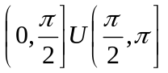  R: 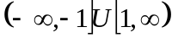 | 5. y = Arcsecx D:(-∞,-1]U[1,∞)  R:
6. y = cscx D: 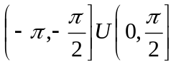  R: | 6. y = Arcsecx D:  R:

Example 7.1 Find the exact values of the following:

- Arcos 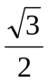 Ans. 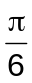
- 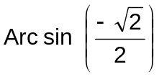 Ans. -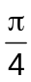
- Arcos 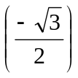 Ans. 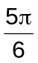
- 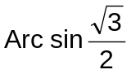 Ans. 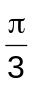

e) 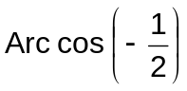 Ans. 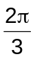

Exercise 7.1 Find the exact value of each expression:

1. 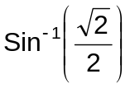 8. 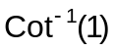

2. 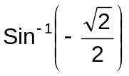 9. 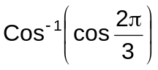

3. 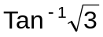 10. 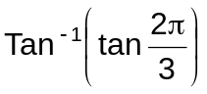

4. 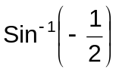 11. 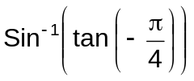

5. 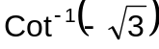 12. 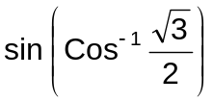

6. Arcsec 2 13. 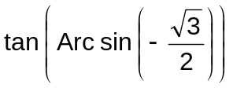

7. Arctan 2.253 14. tan ( Arctan 0.6)

